Context Level DFD for Ambulance Service Provider:

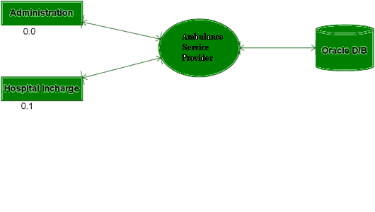

Level 0 DFD for Administration:

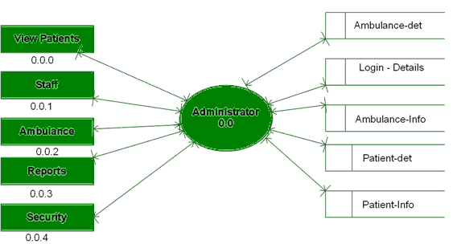

Level 1 DFD for Staff of Admin:

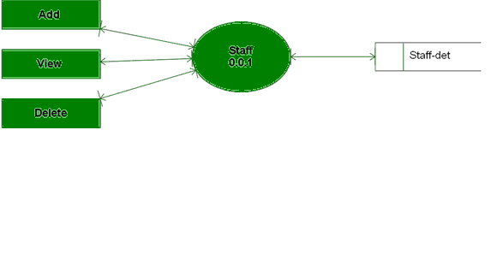

Level 2 DFD for Adding Hospital Staff:

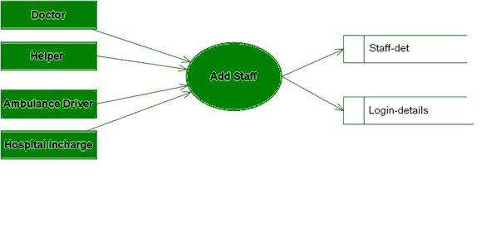

Level 1 for Ambulance of Admin:

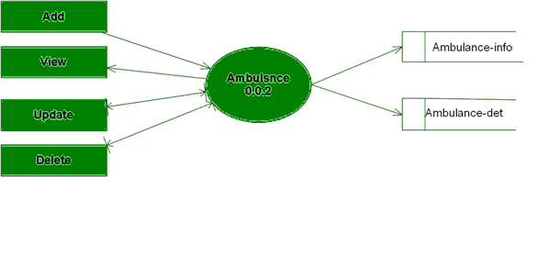

Level 1 DFD for Admin Reports:

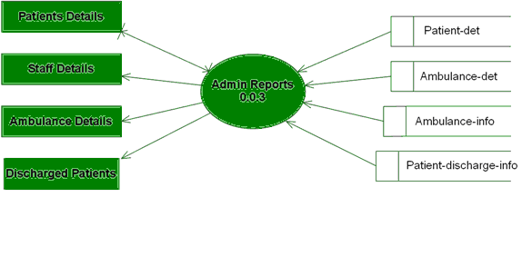

Level 1 DFD for Security of Admin:

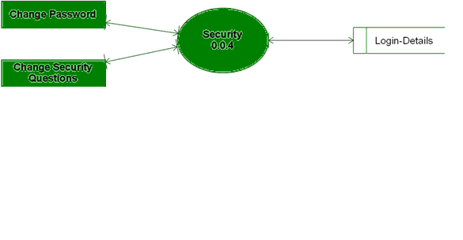

Level 0 DFD for Hospital In charge:

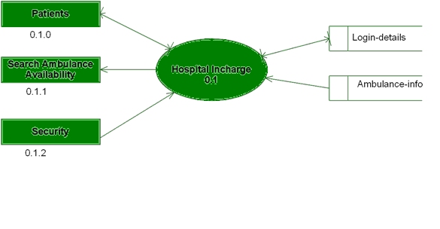

Level 1 DFD for Patients Details:

